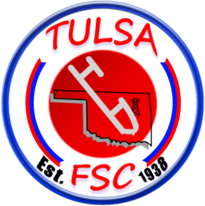
Learn to Skate
Skills Focus Series
Tulsa Figure Skating Club will be offering a six-week Skating Skills Focus Series on Thursday’s from 5:00-5:15pm, April 27th –June 1st. This is for students currently enrolled in LTS; this 15 minute class will focus on a different element each week. This class will be taught by one of the clubs coaches. This class is to enhance the LTS class, not replace it.
April 27th - Stroking, forward/backward Snowplow Stops, & Fwd. /Backward One Foot Glides
May 4th – Two Foot Spins, Lunges, & Slaloms/ Snowplow Stops in Combination
May 11th – Moving Forward to Backward Two foot Turns, Pivots, & Hockey Stops
May 18th – Forward Crossovers, Backward Half Swizzles Pumps, & Backward Stroking
May 25th- Two Foot Turns on a circle, Beginning One Foot Spin
June 1st - Side Toe Hops, Bunny Hops, & Shoot the Ducks
Total Cost of class for 6 weeks $20.00, Check payable to TFSC.
Checks can be dropped off at the counter at the rink.
For more information contact Robert Baker, Robert@Tulsafsc.com

Skater Name______________________________________
Email____________________________________________
Phone #_________________Parent____________________

